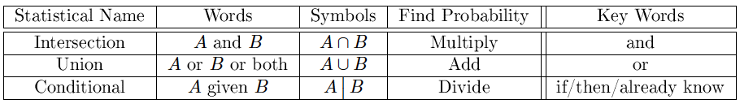

Sample space: all possible outcomes

A’ : everything in sample space not in A

AUB: everything in A or B or both

AnB: outcomes that are in A and B

P(A|B): probability of A if we know B

AnB = BnA

AUB = BUA

Complement Rule:

Union: 

Intersection: 

Conditional Probability: 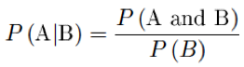

Bayes’ Theorem (reverse the conditional prob): 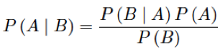

At least 1 => 1-P(none)

If A and B are disjoint, P(A and B)=0

If A and B are disjoint, P(A or B)=P(A)+P(B)

A and B are independent if P(A | B)= P(A)

If A and B are independent, P(A and B)= P(A)*P(B)

Drawing k obs from n objects, with replacement, there are nk outcomes

Permutations:

We want to select k objects from n objects, we select without replacement, and the order of objects matters.

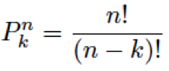

Combinations:

We want to select k objects from n objects, we select without replacement, and the order of objects doesn’t matter.

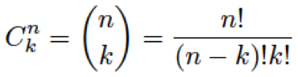

pmf: The set of probability values p assigned to the x values for the random variable X, for discrete random variables.

P values must satisfy: 0<p<1, p+p+…+p=1

cdf: Function describing random variable X.

F(x)=P(X<=x)

pdf to cdf: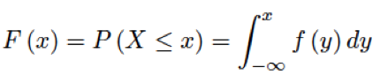

cdf to pdf: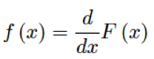

pdf to probabilities: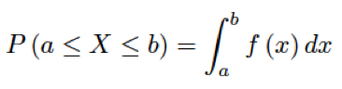

cdf to probabilities:

Quantiles: F(x)=p

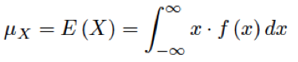

(1-m)^2(.36) + (2-m)^2(.28)+

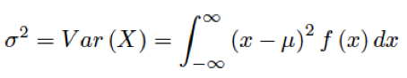



Means:

Rule 1: If X is a random variable and a and b are constants, then:



Rule 2: If X and Y are independent random variables, then:



Variances and standard deviations:

Rule 1: If X is a random variable and a and b are constants, then:



Rule 2: If X and Y are independent random variables, then:



Discrete:

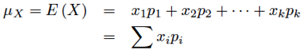

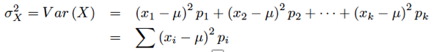

Continuous:

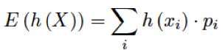

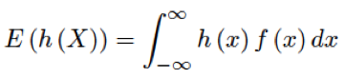

**Binomial Distribution:**

Counts the number of successes.

Requirements: fixed number of observations, n, all independent observations, each is either success or failure, p is the same for each observation.

If we want to find the probability of k successes with n trials and p probability of success: 

Mean: 

Standard deviation:

P(x>7) = P(x=8) + P(x=9) + P(x=10) 